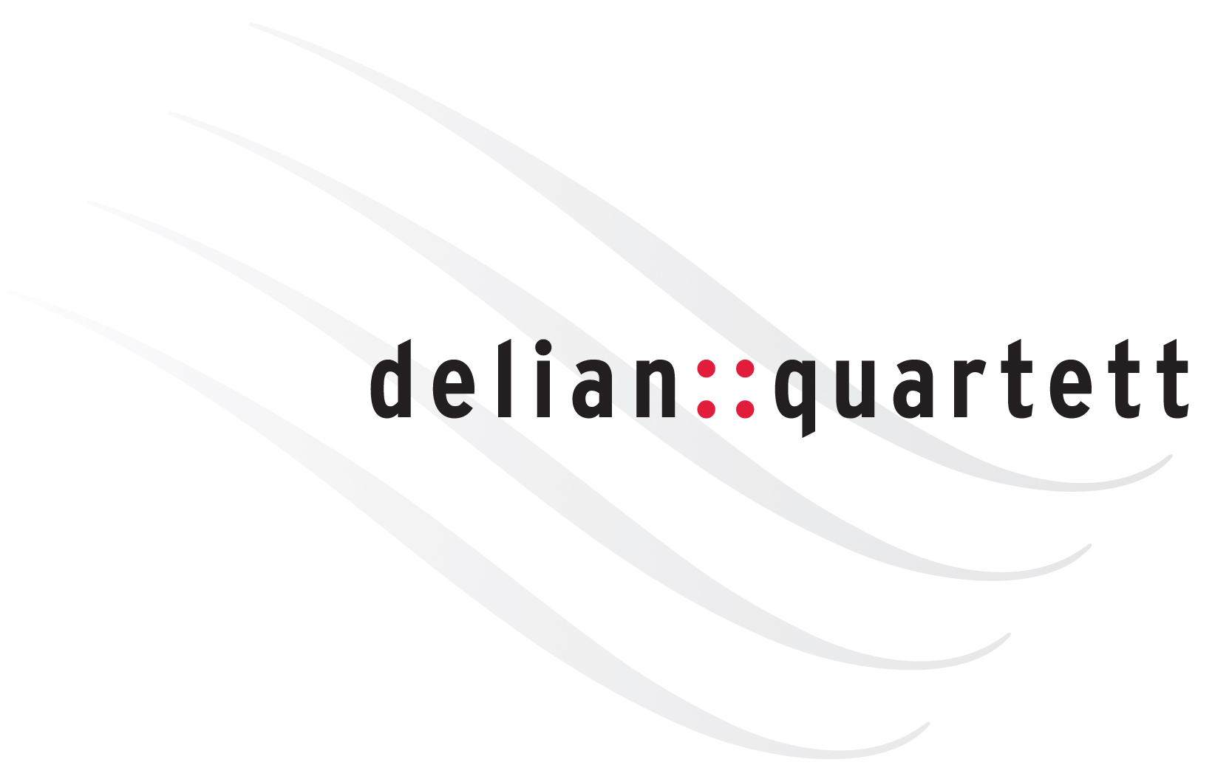
::biography

The namesake of the delian::quartett is the Greek god Apollo who was worshipped as god of the fine arts, and also named Delian after his place of birth, the island of Delos. Ever since the year it was founded in 2007 the doors of the big houses and important festivals opened for the delian::quartett. The echo of the ensemble’s first concerts catapulted them “practically overnight” (Die Rheinpfalz) right to the centre of the international concert scene. The debut of the delian::quartett at the Berliner Philharmonie in 2009 sparked off genuine torrents of enthusiasm; the Quartet was received with standing ovations already after the opening piece. Since then the ensemble has performed, acclaimed by public and press alike, in major concert seasons in all of Europe and – as artistic ambassadors of the Goethe Institute – as far afield as Africa. The delian::quartett’s unconventional and suggestive programmes make many of the Delian-projects an “authentic event” (Bonner General-Anzeiger) and a “fascination” (Frankfurter Neue Presse). Their “breathtaking interpretations” (Ostthüringer Zeitung), which appear like a “new birth from the spirit of music“ (Westdeutsche Allgemeine Zeitung), regularly attract attention. The ensemble’s unique personality as a whole also meets with great appreciation: a “wonderful sonority and striking plasticity of structures” (Frankfurter Allgemeine Zeitung), in the face of which even so always ruled: “truth goes here before beauty” (Der Tagesspiegel). Repeatedly the “premium wine delian::quartett“ (Radio France) has been portrayed by press and various broadcasting corporations or presented to a wide audience in live recordings of their performances. The ensemble’s CD-recordings took top places in the classical music charts and were honoured, as „a subtle and rewarding performance“ (the Strad), with “highest possible marks on the entire line” (Klassik Heute). A big commitment of the ensemble applies the enlargement of the repertoire. Several works have been inscribed to and premiered by them. In 2019 Aribert Reimann dedicated his opus on Schumann’s “Frauenliebe und -leben” to the delian::quartett and soprano Claudia Barainsky. The delian::quartett’s musical guests include artists such as Gilles Apap, Measha Brueggergosman, Gérard Caussé, Stella Doufexis, Per Arne Glorvigen, the Henschel-Quartett, Sergei Nakariakov, Menahem Pressler, Anatol Ugorski and many more. The Delians have shared ten years of their artistic life with the great actor Bruno Ganz, up to his death in 2019, with several spectacular reading-projects.
Since 2017 the members of the delian::quartett appear as Pirastro-Artists and partners of the renowned string manufacturer. Adrian Pinzaru plays a violin by Giovanni Battista Rogeri, generously passed on to him by Christine Anderson; Andreas Moscho’s violin by Giovanni Francesco Pressenda is a big-hearted permanent loan from the Paderborn families Lödige and Jacoby.

