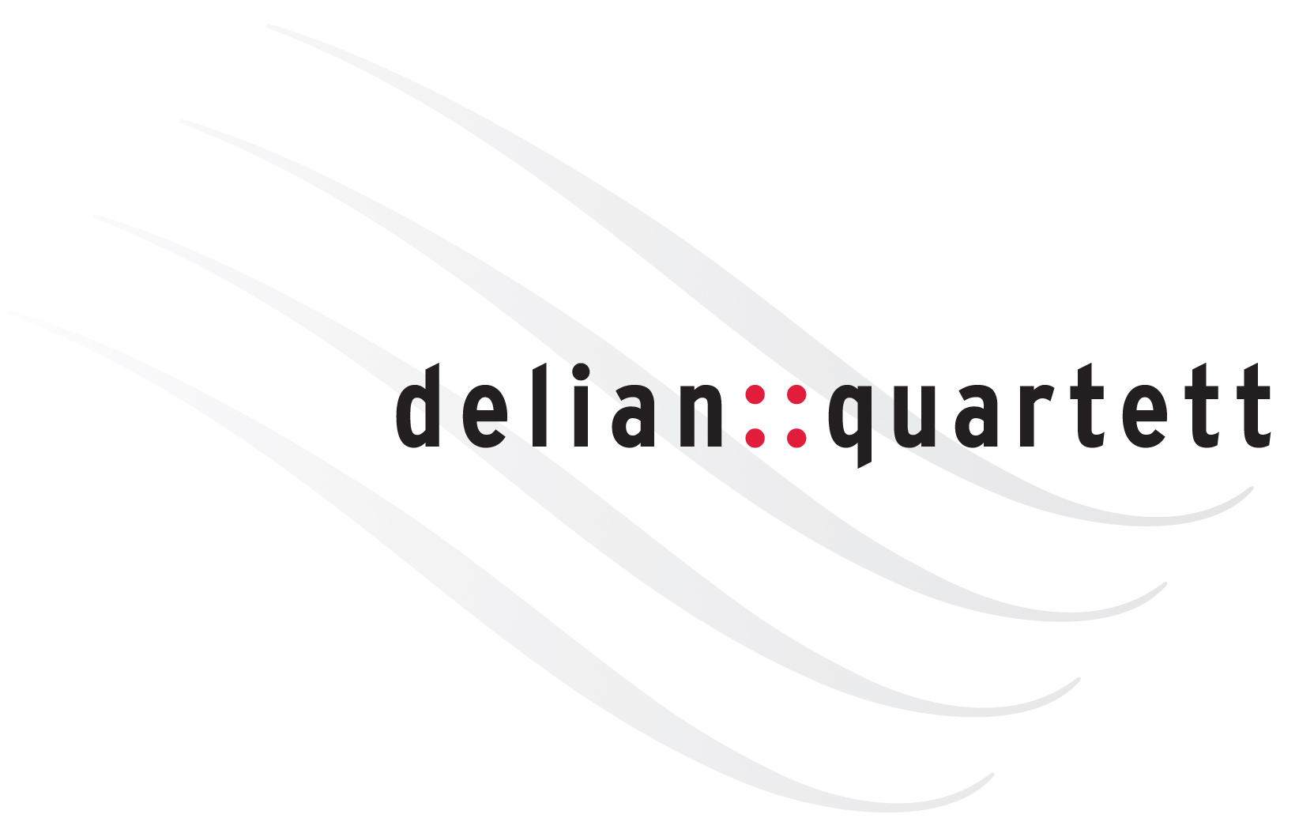
::biography

„[... Inventive and lined with esprit, dramaturgically daring and exciting in terms of content:] even long-time regular visitors to the concert series will hardly make a find in their memories if they are looking for an evening in which all of these characteristics were interwoven as artfully and convincingly as in the performance of the Delian Quartet […] If it needed a proof of the extraordinary class of the [ensemble] - in these breathless seconds […] it appeared with the power of a supernova. […] Thanks for opening a new door to the music world.” (Süddeutsche Zeitung)
The namesake of the delian::quartett is the Greek god Apollo who was worshipped as god of the fine arts, the muses and especially music, and also named Delian after his place of birth, the island of Delos.
Ever since the year it was founded in 2007 the doors of the famous concert halls and important festivals opened for the delian::quartett. The echo of the ensemble’s first concerts catapulted them “practically overnight” (Die Rheinpfalz) right to the centre of the international concert scene. The debut of the delian::quartett at the Berliner Philharmonie in 2009 sparked off genuine torrents of enthusiasm; the Quartet was received with standing ovations already after the opening work. Since then the ensemble has performed, acclaimed by public and press alike, in major concert seasons in all of Europe and – as artistic ambassadors of the Goethe Institute – as far afield as Africa. It has been a celebrated guest in venues such as Konzerthaus Berlin, Alte Oper Frankfurt, Prinzregententheater München, Unione Musicale Turin, Konzerthaus and Musikverein Vienna, Tonhalle Zurich, Beethovenfest Bonn, Kissinger Sommer, Ludwigsburger Schloßfestspiele, Settimane Musicali Meranesi, Rheingau Musik Festival, Schleswig-Holstein Musik Festival or Schubertiade Roskilde.
The delian::quartett’s unconventional and suggestive programmes make many of the Delian-projects an “authentic event” (Bonner General-Anzeiger) and a “fascination” (Frankfurter Neue Presse). Their “breathtaking interpretations” (Ostthüringer Zeitung), which appear like a “new birth from the spirit of music“ (Westdeutsche Allgemeine Zeitung), regularly attract attention. The ensemble’s unique personality as a whole also meets with great appreciation: a “wonderful sonority and striking plasticity of structures” (Frankfurter Allgemeine Zeitung), in the face of which even so always ruled: “truth goes here before beauty” (Der Tagesspiegel).
Vigorous cooperation binds the delian::quartett with various broadcasting corporations such as the SWR, HR, WDR, Catalunya Música, Radio France, Danmarks Radio, BR, NDR, SR, ORF and Deutschlandfunk, which have broadcast live recordings of their performances, presented the “Grand Cru delian::quartett “ (Radio France) in diverse portrait broadcasts and co-produced the CDs of the ensemble. The recordings of the Quartet with the label OehmsClassics took top places in the classical music charts and were honoured, as „a subtle and rewarding performance“ (the Strad), with “highest possible marks on the entire line” (Klassik Heute). Numerous broadcasting stations presented them as the editor’s choice, and they have been part of the Album Selection at Lufthansa several times. The delian::quartett’s debut CD with works of Robert Schumann was followed by a recording of music by Joseph Haydn, which was awarded a nomination for the Echo Klassik 2010. Further recordings present the oeuvre by Ludwig van Beethoven and Dmitri Shostakovich. In 2018 the delian::quartett‘s acclaimed performance of Chausson’s Concert for Violin, Piano and String Quartet op. 21, together with Liza Ferschtman and Benjamin Moser, was included as a live-recording in the Jubilee-Edition Klavier-Festival Ruhr. In the same year the ensemble’s double CD “Cantai” was released, with Bach‘s “Art of Fugue” and Pierini’s „Cantai un tempo…“, which had been written for the delian::quartett. “Giving us all of the music’s stunning complexity, and taking us on a breathtaking intellectual ride in which both clarity of musical argument and a sense of joy are communicated” (MusicWeb International), this recording was awarded, amongst others, five stars by the Italian ARCHI magazine and a nomination for the OPUS KLASSIK 2019.
A big commitment of the delian::quartett applies the enlargement of the repertoire. They have premiered works by living composers Alberto Colla, Per Arne Glorvigen, Gabriel Iranyi, Christian Jost, Stefano Pierini and Uljas Pulkkis; most of those works have been inscribed to the Quartet. In 2019 Aribert Reimann dedicated his opus on Schumann’s “Frauenliebe und -leben” to the delian::quartett and soprano Claudia Barainsky. With “Hey Klassik!”, the fun and “totally super-cool” (children's voice) Delian-format for the young and the young at heart, the ensemble also gets newcomers enthusiastic about classical music.
The delian::quartett’s musical activity has received enrichment and additional inspiration through regular performance with other artists of international stature in expanded ensembles. The guests of the Quartet include Gilles Apap, Fabio Bidini, Measha Brueggergosman, Gérard Caussé, the Deutsche Kammerakademie Neuss, Stella Doufexis, Andreas Frölich, Pavel Gililov, Bernd Glemser, Per Arne Glorvigen, the Henschel-Quartett, Ralph Manno, Sergei Nakariakov, Ulrich Noethen, Menahem Pressler, Dora Schwarzberg, Ulrich Tukur, Anatol Ugorski and many more. The Delians have shared ten years of their artistic life with the great actor Bruno Ganz, up to his death in 2019, with several spectacular reading-projects.
Since 2017 the members of the delian::quartett appear as Pirastro-Artists and partners of the renowned string manufacturer. Adrian Pinzaru plays a violin by Giovanni Battista Rogeri, generously passed on to him by Christine Anderson; Andreas Moscho’s violin by Giovanni Francesco Pressenda is a big-hearted permanent loan from the Paderborn families Lödige and Jacoby.

